

Deployment Planning Handbook

CDMA 1xEV-DO Release 8.0

______________________ Final 1.0

Issue Date:

Security Status: Nortel Confidential

©2008 Nortel

All rights reserved

CONTROLLED COPY:

Any hardcopies taken must be regarded as uncontrolled copies.

A soft copy of the latest version of this document is located at:
http://livelink-ott.ca.nortel.com/livelink/livelink.exe?func=ll&objId=33069324&objAction=browse&sort=name&viewType=1

NORTEL CONFIDENTIAL: The information contained in this document is the property of Nortel. Except as specifically authorized in writing by Nortel, the holder of this document shall: (1) keep all information contained herein confidential and shall protect same in whole or in part from disclosure and dissemination to all third parties and (2) use same for operating and maintenance purposes only.

Document Revision History

Revision | Date | Author | Description
0.1 | 3/12/09 | J Montgomery | Initial Draft of the 8.0 Handbook
0.2 | 4/10/09 | J Montgomery | Additional updates to NTP, IM, Newtun and various broken links.
1.0 | 6/8/09 | J Montgomery | For review.

Approvals 1xEV-DO Release 8.0

Functional Area | Approver | Date
Network Engineering | Xiao, Wu (RICH1:1766)
RF Engineering | Phommachakr, Santisouk (WIC:W788)
Network Engineering Tools-NEWTUN  -CPS | Cuong Vo  Waseeem Qaraguli
HW SW Engr. Rules | Darrell McChesney  and Charles Powell
Installation/Integration | David Wilburn
WPP | Gerardo Donis
Software Services
Knowledge Services-Doc  - Training | Jane Wooster  Lori Motl
Marketing | Lee Forland
PLM | Leskaroski, Dejan (RICH1:4430)

Table of Contents

1 Introduction 8
1.1 Purpose and Scope 8
1.2 Deployment Handbook Availability 8
2 Product/Solution Description 9
2.1 Product Overview 9
2.1.1 Plan of Record 9
2.2 Baseline Prerequisites 10
2.2.1 Hardware Baseline 10
2.2.2 Software Baseline 11
2.3 Network Design 12
2.4 1xEV-DO 8.0 Compatibility Matrix 13
2.5 Notice of Intent/Notice of Decision 13
2.6 Communication 14
3 Pre-Sales Phase 15
3.1 Product Promotion 15
3.2 Engineering 16
3.2.1 Materials Estimate (ME) 16
3.2.2 Hardware CIQ / Network Design Document (NDD) 16
3.2.3 Provisioning Tool and Guidelines 16
3.2.4 Control Channel and Access Channel Capacity Analysis 16
3.2.5 1xEVDO Backhaul Provision White Paper 16
3.2.6 1xRTT and 1xEV-DO Differential Backhaul Delay 16
3.2.7 Call Flow and KPI/KCI Package 17
3.2.8 RF Parameters and Datafill Guide 17
3.3 Hardware Ordering 18
3.3.1 DO-EMS Hardware 19
3.3.2 DO HC-RNC Hardware 20
3.3.3 HC-RNC Recommended Sparing 21
3.3.4 HC-RNC Field Replaceable Units 22
3.3.5 Product Financial Codes 22
3.3.6 Hardware Royalty 22
3.4 Software Ordering 23
3.4.1 Software Order Codes 23
3.4.2 CLLI Management 23
3.4.3 Release Software 23
3.4.4 Software Shipment Tracking 23
3.4.5 Software Royalty Commitments 24
3.4.6 Software Order Codes 24
3.4.7 Right To Use Codes 25
3.4.8 CCDS/CFDS Key Codes 26
3.5 Encryption 26
3.5.1 Hardware Pre-Loaded with Ciphering Software 27
3.6 Off Board Tool Ordering 27
3.7 Market Project Management 28
4 Build/Deploy Phase 29
4.1 Product Engineering Information 29
4.2 Engineering Tools 29
4.2.1 Software CIQ 30
4.2.2 NEWTUN 30
4.2.3 CPS (Common Provisioning System 31
4.3 Installation Methods 33
4.4 Integration Methods of Procedure Strategy 34
4.4.1 Acceptance Test Strategy 34
4.5 Installation Return Process for non In-Service Nodes 35
4.6 Software Installation/Upgrade 36
4.7 New Feature Provisioning 38
5 Operate/Maintain Phase 39
5.1 Service Entitlements 39
5.2 Customer Documentation 39
5.3 Nortel Internal Training 40
5.3.1 External / Customer Training 41
5.4 Performance Monitoring 42
5.4.1 Utilizing the Network Performance indicators and formulas 42
5.4.2 Key Performance Indicators/Key Capacity Indicators 42
5.4.3 Product Performance – WPP – Nortel Wireless Performance Portal 43
5.4.4 WPP Service Support 45
5.4.5 WPP Documentation 45
5.4.6 WPP Marketing Collateral 46
5.5 Corrective Content 46
5.5.1 Current EV-DO Patch Baseline 46
5.5.2 Web Posting 46
5.5.3 Drop Box Delivery 46
5.5.4 Patch Download 47
5.5.5 Corrective Content Management 47
5.5.6 CDMA Load Lineup 47
5.5.7 Patch Disposition Reports 47
5.6 Technical Support Model 47
5.6.1 Required Tools 47
5.6.2 Health Check Procedure 48
5.6.3 Product Clarify Queues 48
5.6.4 Global Product Support Teams 48
5.6.5 GNPS Routing Map 48
5.6.6 Documentation 48
5.6.7 E1/E2 Criteria and Outage Impact Calculations 49
5.6.8 Validation Matrix 50
5.7 Repair & Return Process for In-Service Nodes 50
5.7.1 Global Customer Investigation Process (GCIP) 51
5.8 Communication 51
5.8.1 Product Release Notes 51
5.8.2 Wireless Customer Advisory Bulletins 51
5.8.3 Field Bulletins 52
5.8.4 Wireless Engineering Product Bulletins 52
6 References 53
6.1 Reference Links 53
6.2 Acronyms 54

Table 1: Product Financial Codes 22
Table 2: Tool PEC Listing 28
Table 3: NTP List 39
Table 4: Formal Training Courses 41
Table 5: Validation Matrix 50

Introduction

Purpose and Scope
The Deployment Planning Handbook is a centralized repository for process and technical information critical to the deployment of the new products into the various regions/markets/customers. The target audience for this document is generally the market project managers, account teams and customer facing support teams.

The Handbook provides quick, easy access to relevant information in one central location for the Service Process Operators. The intent is to consolidate the wealth of information that is available for new programs to reduce the need to search for multiple documents and/or hunt-down the Subject Matter Expert for typical deployment related information.

This document contains information relevant to assist in the deployment of new products/solutions, including information specifically for each of the Service functional roles (Engineering, Installation, Integration, Tech. Services, etc.).

The Handbook is a job-aid focused on the Channel Ready through End of Life phase of our product introduction. Included in this handbook are the critical process, tools, and documentation necessary for product deployment and maintenance.

The handbook is divided into five major sections:
- Program Information
- Pre-Sales Phase
- Order Phase
- Build/Deploy Phase
- Operate/Maintain Phase

Deployment Handbook Availability
This Document is primarily delivered at the milestones listed below. Following Channel Readiness milestone additional modification will be made as needed to ensure continuous successful deployments.

CR | Preliminary version of Deployment Planning Handbook
ChR | Final Deployment Planning Handbook, with end user validation

Product/Solution Description

Product Overview
The Nortel Release EVDO 8.0 delivers performance enhancements, flexibility, robustness, and efficiency. to continually improve the end-user, as well as, the operator experience.
1xEV-DO Rev A Release 8.0 is fully backward compatible with 1xEV-DO Rev 0 protocol and CDMA 1xRTT (however DOM-0 hardware will not be supported on an EVDO 8.0 software release and beyond)

Plan of Record
The following features are in the POR as it stands for 1xEV-DO Rev A Release 8.0. The POR can be found at URL: http://livelink-ott.ca.nortel.com/livelink/livelink.exe?func=ll&objId=30005476&objAction=browse&sort=name&viewType=1
1xEV-DO Release 8.0 Features
1xEV DO Rev A & RF Perf
  - A13 Trigger Enhancements
  - Application Traffic Type Paging Scheme
  - Threshold Crossing Alarms for ACH & CCH

RNC Platform
  - RNC Cluster Load Balancing
  - RNSM Load Balancing
  - Cluster Increase for RNC8600 (8 to 10)
  - NE Robustness

BTS – DOM and Backhaul
  - ROT for MFRM1/MFRM2

EMS Enhancements
  - DO-EMS Enhancements
  - Generic Group Operations
  - Network Inventory Feature
  - DO-EMS Robustness
  - Common Provisioning System (CPS) Tool

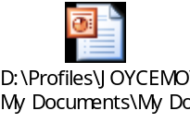

For more information, information on the Release 8.0 features, review the following NTPs:
  - 411-2133-212 “What’s New in this Release
  - 411-2133-109 V1 & V2 “Release Delta (7.0 to 8.0)”

Baseline Prerequisites

Hardware Baseline

BTS
Nortel provides a wide BTS portfolio, each able to host DOM-0 and/or DOM-A with the Metrocell allowing up to six DOMs total (maximum of three DOM-0s)

DOM-0 (Data Optimized Module, Rev 0)
This node is currently MD’d with an EOL in 2012.
This node is NOT supported in EVDO Release 8.0.
The replacement for this node is the DOM-A

DOM-A (Data Optimized Module, Rev A) under 2 PECs
Generally Available and supported (under PEC NTBW89DAE5 but being replaced by NTBW89SB due to component obsolesces)

RNC8500 (Radio Network Controller)
This node is currently MD’d with an EOL in 2012.
This node is supported in 1xEV-DO Rev A Release 8.0.
The replacement for this node is the HC RNC8600.

HC RNC8600 (High Capacity Radio Network Controller)

Generally Available and supported.

DO-EMS (Element Manager Subsystem) Netra 20

This node is currently MD’d and is EOL with 7.0 Channel Ready.

DO-EMS (Element Manager Subsystem) Netra 440x2CPU

This node is supported in 1xEV-DO Rev A Release 8.0.

DO-EMS (Element Manager Subsystem) Netra 440x4CPU

This node is supported in 1xEV-DO Rev A Release 8.0.

DO-EMS (Element Manager Subsystem) CCMP6000
This node is first introduced in 1xEV-DO Rev A Release 7.0 for the DO-EMS Application.

CDMA 1xRTT EBSC (Enhanced Base Station Controller)
If considering an EVDO-only solution (without 1xVoice/Data), the EBSC is still required to manage the BTSs that host the DOMs.

PDN16K
This node is required to terminate the end-user’s PPP-session and serves as the gateway to the Internet or the operator’s packet data network. An existing 1xData PDSN can be also be used for 1xEV-DO.

AAA

Authentication is optional in the 1xEV-DO network, but recommended.

Software Baseline

Minimum software load required before upgrading to Release 8.0 is:

At the Radio Access Network (RAN):
  - • DOM-A, DO-RNC, DO-EMS with DO release 7.0
  - • DOM-A with optional CFDS
  - o Rev A & QoS CFDS for Rev A & QoS services
  - o PTT/VoIP CFDS for real-time applications.
  - • BTS and BSC with the NBSS16.0 or higher.

At the Core network:
  - • PDSN16K with PDN release 7.1 and optional Rev A/QoS license enabled.
  - • AAA Bridgewater with S/W load 8.2

1xEV-DO Release 8.0 Software Baseline

ChR load lineup
EMS App 8.0.0.191
Ems Platform 8.0.0.184 (unchanged from VO1 load lineup)
RNC 8.0.0.143
DOM A 8.0.0.136 (unchanged from VO1 load lineup)

DOM-0 Not Supported

Network Design
PDN 7.1 is required for Rev A and QoS functionality on RAN.

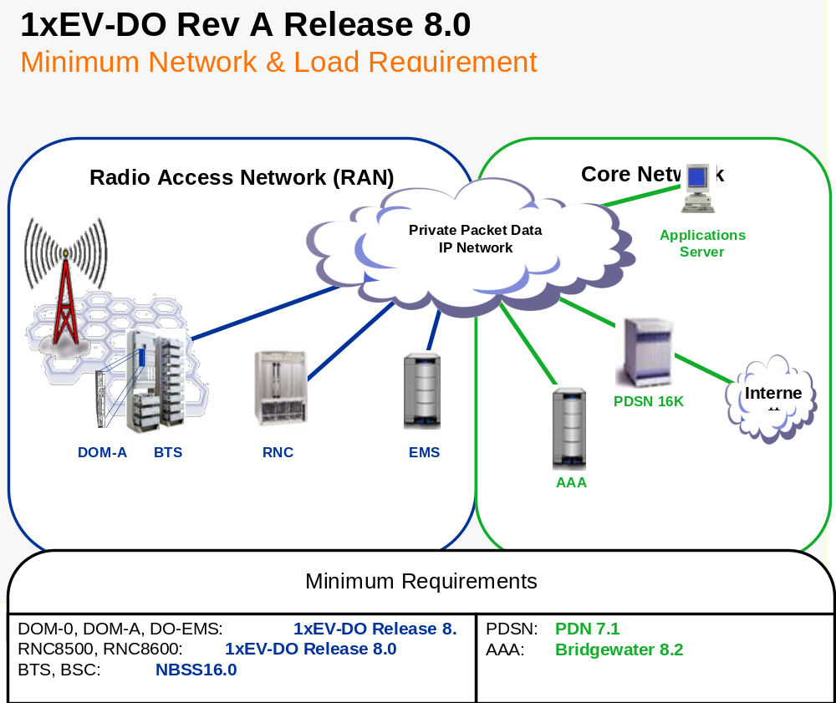

1xEV-DO 8.0 Compatibility Matrix
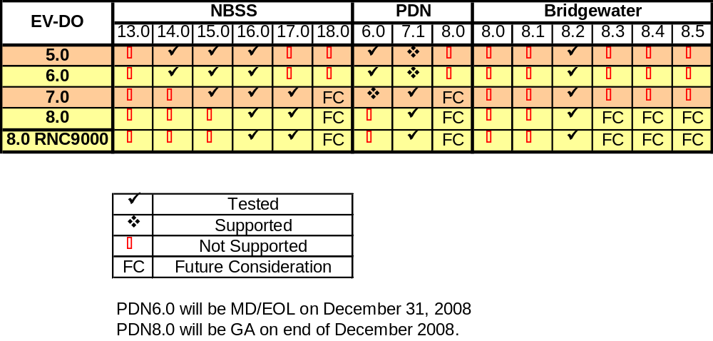

Notice of Intent/Notice of Decision
With the introduction of the 8.0 Software, the 6.0 release will be manufacture discontinued with the Channel Ready declaration of release 8.0

The Notice of Intent/Decision for software is available at this location:
http://livelink-ott.ca.nortel.com/livelink/livelink.exe?func=ll&objId=13061545&objAction=browse&sort=name&viewType=1

Notice of Intent/Decision for hardware is available at this location: http://livelink-ott.ca.nortel.com/livelink/livelink.exe?func=ll&objId=17393503&objAction=browse&sort=name&viewType=1

DOM-A has the same form factor as DOM-0 and DOM-A can be co-located with the DOM-0. DOM-0 is being MD’d as a strategy to streamline the BTS portfolio. It is expected that in 2H2006, all customers will start moving to the DOM-A product. DOM-A does require a minimum of 1xEV-DO Release 3.2. DOM-0 was manufacturer discontinued in February 05, 2007 and will no longer be supported by Nortel after first quarter 2012. Further the EVDO8 loads and beyond will not work on an EVDO0 card. There will be no DOM-0 load on the NCL disk for CDOR0080. Further the EMS load will not upgrade to any version of EVDO 8 load with a DOM-0 in its structure.

Table of DOM-0/DOM-A Product Codes comparison
PRODUCT TO MD |  |  | REPLACEMENT
PEC | CPC | DESCRIPTION | PEC | CPC | DESCRIPTION
NTBW99DO | A0886295 | 1XEVDO DATA ONLY MODULE Rev 0 | NTBW89DA | N0032774 | 1XEVDO DATA OPTIMIZED MODULE Rev A
NTBW90AA | A0898161 | EVDO RNC-Fully Populated | NTBW90ABE5 | N0096672 | EVDO 8600 RNC-Fully Populated
NTBW89DA/NTBW89DAE5 | N0032774/N0115041 | 1XEVDo Data Optimized Module Rev A | NTBW89SB | N0197662 | 1XEVDO Data Optimized Module Rev A

The 1xEV-DO 8500 Radio Network Controller (RNC) was replaced by the 1xEV-DO 8600 Radio Network Controller combined with the 1xEV-DO Software Release 4.0 or higher. The 1xEV-DO 8500 RNC will be Hardware Manufacture Discontinued (MD) as of February 29, 2008 and no longer available for order; and Hardware End of Life will be reached Q1 2012 when Nortel will no longer support the product. Most features that are introduced in EVDO Software Release 7.0 and prior releases will continue to be supported on the 1xEV-DO 8500 Radio Network Controller until the Hardware End of Life. No new software features will be introduced on 1xEV-DO 8500 Radio Network Controller in EVDO Software Release 8.0 and beyond.

Activity | Targeted Date
NOI distribution (8500 RNC) | August 28, 2007
NOD distribution (8500 RNC) | Jan 25, 2008
PRN distribution 1 | Jan 31, 2008 – R1 (added line cards)
Hardware Manufacture Discontinue³ | Feb 29, 2008
S/W freeze (8500 RNC)2 | EVDO Rel 8.0
S/W MD4 | Q2/2011 (Est EVDO Rel 12.0) – last supported release
EOL (H/W & S/W)5 | Jan 31, 2012

Communication
Periodic information will be posted at the CDMA Solutions web site. To access the 1xEV-DO specific bulletins, follow this path: http://www.nortelnetworks.com/cdmacommunity
Then select File Exchange, then Product Bulletins, then 1xEV-DO Product Bulletins.

Pre-Sales Phase
The Pre-Sales phase defines the period prior to the actual product order. During this phase the objective is to accurately capture customer engineering, capacity, and deployment expectations. The final outcome of this phase provides detailed system definition documents (including hardware CIQ documentation) with which to initiate an actual order and deployment plans. Key functional team involvement during this phase is required by regional, customer, and sales engineering teams.

Product Promotion
CDMA 2000 1xEV-DO (Evolution Data Optimized) is a packet data system offering broadband wireless services with the current throughput up to 2.4 Mbps in the forward link. Field-proven technology, 1xEV-DO meets the ITU 3G requirement today. It delivers up to 3 to 6 times the capacity of 1x at the same 1.25 MHz channel bandwidth.

To review Customer Presentations and other marketing materials, please access the Marketing web site on BizSphere at URL: http://go/evdo

Engineering

Materials Estimate (ME)
Region Engineers are required to generate and maintain ME's using the Pathfinder tool.

Hardware CIQ / Network Design Document (NDD)
The Hardware CIQ is a workbook containing key customer and site information; as well as, questions to determine the hardware and configuration of the 1xEV-DO system. It must be completed by both regional engineers and customer representatives. Among other key information the CIQ contains: Call Model, Dimensioning, Configuration, Connectivity and IP Planning information.

The NDD contains further information to graphically represent the nodes and the system configuration. Together, when complete and concatenated, these two documents define a "Final Network Design".

The 1xEV-DO CIQs and NDDs are located at the following link: http://livelink.us.nortel.com/livelink/livelink.exe?func=ll&objid=12333817&objAction=browse&sort=name

Provisioning Tool and Guidelines
1xEV-DO Provisioning Guide provides the provisioning rules and procedures for a 1xEV-DO system:
http://livelink.us.nortel.com/objectid/12333816

This information is also found in Appendix A of the 411-2133-932 1xEV-DO Deployment Planning NTP.

Control Channel and Access Channel Capacity Analysis
1xEV-DO Control Channel and Access Channel Capacity Analysis is released for Release 5.0. Release 8.0 has no new CCH and ACH features so the Release 5.0 study is still valid. And can be found at URL: http://livelink.us.nortel.com/livelink/livelink.exe/open/12472404

1xEVDO Backhaul Provision White Paper
This provisioning paper can be found at: http://livelink.us.nortel.com/objectid/12333816. This document was written in Release 4.0 and is still relevant to Release 8.0

1xRTT and 1xEV-DO Differential Backhaul Delay
1xRTT and 1xEV-DO Differential Backhaul Delay Package is based on NBSS 15 and DO R5.0; however there are no changes specific to NBSS 16 and DO 8.0 so this document is still valid. It can be found at: http://livelink.us.nortel.com/objectid/12472313

Call Flow and KPI/KCI Package
http://livelink.us.nortel.com/livelink/livelink.exe?func=ll&objId=12472404&objAction=browse&sort=name

RF Parameters and Datafill Guide

http://livelink.us.nortel.com/livelink/livelink.exe?func=ll&objId=9185811&objAction=browse&sort=name

Order
The Order phase defines the period after a system definition and planning has completed and the actual order is ready for submission. The outcome of this phase is a completed software and hardware order.

Key functional team involvement during this phase is order management.

Product order process is via the complex legacy process and tools (MIF/CADES). MIF product and option cods to use are 3V/F9 and aligns with CDMA BSC Ext’n with Data. The manufacturing interval is 4 weeks from receipt of spec.

Hardware Ordering
OAM Engineering and Provisioning Rules can be found at:
http://livelink.us.nortel.com/livelink/livelink.exe/fetch/15399740/Production/EG/EG2006.pdf

RNC Engineering Rules can be found at:
http://livelink.us.nortel.com/livelink/livelink.exe/fetch/15399740/Production/EG/EG2009.pdf

The following tools exist for the purpose of completing hardware ordering. Card level knowledge, quantities required (Hardware CIQ input) is a prerequisite for successful use of these tools.

The Wireless Process order flows have been mapped and are available at this location:
http://zrtps091.us.nortel.com:8088/livelink/livelink?func=ll&objId=2281329&objAction=browse&sort=name

Product Financial Codes
In order for revenue to be properly captured, each product receives a code for financial transactions. These codes are applied to the financial system (appropriate for the region) by Order Management when the order is received. (The financial product code is also known as the “Seg 5” code.)

Table 1: Product Financial Codes
Product | Financial Product Code
EVDO rA | 510925

Software Ordering

Software Order Codes
Reference the EG0601: Wireless Software Engineering Guide for more details.

To enable the Patch Services organization to begin Patching services for a new or existing customer, please follow the instructions provided at the link below to submit your service request:
http://swf.ca.nortel.com/live/sif.html

The Wireless Software Delivery process is documented in the “Carrier & Wireless SW Delivery Strategy” document. The document is available at the following URL:
http://swsi.ca.nortel.com/supplychains.htm

Software Operations is responsible for the delivery of all Wireless software. Standard process is followed via SCS/UNITE.

The US/CaLA Wireless Software Ordering Process is available at this location:
http://zrtps091.us.nortel.com:8088/livelink/livelink/4227523/US_CaLA_Wireless_SW_Ordering.ppt?func=doc.Fetch&nodeid=4227523

CLLI Management
All Wireless software orders require a unique site identifier, either a Common Language Location Identifier (CLLI) or Nortel Site Location Identifier (NSLI).

A CLLI is generated by Telcordia for the customer. In some situations (e.g. outside of North America), Nortel can provide an NSLI. If an NSLI is required, the request is made through the following web tool. Peripheral equipment can use the switch CLLI/NSLI, as long as the equipment is located at the same address. http://gsds.ca.nortel.com/CMW/

When your customer has an initial MSC, HLR, MSC/HLR or CCA, the CLLI/NSLI must be recorded using this web site: http://gsds.ca.nortel.com/CMW

If you have any questions regarding the process, please contact Char Logsdon.

Release Software
Program software ordering is no longer accomplished using the on-line Job Activity Node (JAN) tool in North America. Software jobs are booked via SAP by the Order Manager.

Software Shipment Tracking
Tracking of shipments (internal use only) is available on-line at: http://gsds.ca.nortel.com:8585/cgi-bin/Galaxy/orders/waybill/WB2/waybill.cgi

- Enter the CLLI or Load ID
- Select the appropriate Product Type (s)
- Click View/Edit Shipping List
Once the results are displayed, select the most recent date and then click View
Scroll down to the listings in Green, this shows the shipment details

To view tracking information, scroll to the Grey section and click on the link that says Waybill Information beside Waybill Number (Waybill information may be missing for most international loads because they are shipped via DHL. It takes a couple of days before DHL data is received)

Software Royalty Commitments
Wherever possible, a software royalty will be tracked via its hardware platform for tracking reliability. This is in order to remove the human element of having to order the royalty along with the software (PCA constraints do not allow “auto triggering/selecting” of royalty codes) by placing the royalty tracking code in the hardware stocklist.

Situations which do not facilitate this approach and thus require the purchaser to also order the royalty code are:
- Where no correlation exists between the software and hardware (e.g. - same software can be used on more than a quantity of one piece of hardware at no additional cost).
- Where the software is re-used by Wireless from another LOB (and so must conform to the other LOB’s approach).
- The software is being ordered as an upgrade for equipment already on site

Software Order Codes
SW Order Code | Product Description | 3rd Party Supplier | 3rd Party Program | Royalty PEC | HW PEC
CDOE0080 | E128 CDMA 1XEV-DO ELMT MGMT SYS APP | Arvana | Arvana | TPNN0011 | NTBW98BA/CA  NTBW89SB
 |  | Oracle | Oracle 8i | TPNN0012 | NTBW98BA/CA
CDOR0080 | 1XEV-DO RNC APP 2.2 | Airvana | Airvana | TPNN0014 | NTBW91AA/CA/DA  NTBW89SB
CDON0080 | E128 CDMA 1XEV-DO ELMT MGMT SYS APP  -CCMP6000 | Arvana | Arvana | Xxxx
CPSP0080 | Premium License code for | Na | Na |  | none
Notes
1 Objectivity royalties will be managed (by Wireless Cost Mgmt) on a 1:1 relationship based on the software shipments, not the hardware (NTPX28CA and FA).
2 NTRX51LB was replaced at CR with the LW to capture the 512K -> 1M memory module change.
3 When ordering the CBM sw in an MTX application, SPFS0070 must also be ordered, but only 3/5 possible royalties associated with SPFS0070 are required (LCS00019, TPNN0050, LCS00022).
4 When ordering a packet switch (e.g. - P-MSC), all 5 royalties associated with SPFS0070 are required.

CCDS/CFDS Key Codes
Key codes are used to enable software features or additional hardware capacity. Key codes are divided into two groups - CFDS (Customer Feature Delivery System) and CCDS (Customer Capacity Delivery System). The distinction between these two codes is necessary given the different tax and depreciation rules for software and hardware. CFDS key codes are used to implement software optionality control (similar to SOC on the DMS). CCDS key codes are used to increment hardware capacity. Key codes are enabled by Order Management at http://www.nortelnetworks.com/servsup/krs/ and delivered via the Web to the appropriate network management element. They are then distributed to various processors where they enable additional software feature functionality or to appropriate hardware packs to activate the use of additional capacity.

The process for requesting key codes is found in the document CFDS_CCDS New Feature Process at
http://livelink-asiapac.us.nortel.com/AsiaPac/livelink.exe?func=ll&objId=143774&objAction=browse&sort=name

The following products require a key code to enable software features:

CFDS Codes
Product | PEC | Description
1XEV-DO rev A | NT2J10CV | KRS_DO_REV_A_&_QOS_ENHANCEMENT
1XEV-DO rev A | NT2J10CU | KRS_DO_VOIP_&_PTT_OPTIMIZATION
1XEV-DO rev A | NT2J10CY* | KRS_APRIORI_RESOURCE_ALLOCATION
1XEV-DO rev A | NT2J10EE | KRS_INTER_USER_BEST_EFFORT_ENABLER
*this is Sprint only, and should another customer want to use, PLM should be contacted.

The following products require a key code to enable hardware capacity:

CCDS Codes

Product | PEC | Description
1XEV-DO rev A | NT2J11DB | KRS_AABS_DO_ADDITIONAL_SECTOR
1XEV-DO rev A | NT2J11DA | KRS_DO_CE_CAPACITY_INCREMENT
1XEV-DO rev A | NT2J11DL | Royalty Reporting – One per EMS Server

Encryption
It has been determined that this product contains 168-bit strength encryption. This applies to the software, but as chassis ships with installed software, the hardware is indirectly controlled as well.

Any customers outside of the United States or Canada must submit an End User Certificate (EUC). The EUC identifies the type of end user. Any government or military customers require additional approvals. The EUC also acts as a protection to Nortel; customers must declare that they will not re-export the technology to embargoed countries.

Prior to placing the order, the EUC form must be signed by the customer. The EUC is NOT product specific, but IS customer & country specific. That is, if the customer is in multiple countries, we would need a EUC signed for each of the customer’s countries. The EUC is specific to the country where the product shipment originates. Therefore, to ensure business continuity in the event of a disaster, it is best to have customers sign a EUC form from all countries where an SDC is present.

EUC is not required for domestic shipments, between the U.S. and Canada, or within European Union countries
Reference link: http://livelink.us.nortel.com/livelink/livelink.exe/7101739/Introduction_of_Encryption_Products.ppt?func=doc.Fetch&nodeid=7101739

If applicable, ensure your customer has a EUC on file prior to ordering any of the following products:
- CEMS0140 Netra 440 EMS

The following new CDMA software products contain encryption technology:
SW PEC | SW CPC | Product Name | Encryption Element (SW)
CDOE0032  CDOE0040  CDOE0050  CDOE0060  CDOE0070  CDOE0080  CDON0080 | N0030495  N0112426 | e128 CDMA 1xEV-DO Elmt Mgmt Sys App | Oracle 8i 5D002  Oracle 10

Hardware Pre-Loaded with Ciphering Software
The following hardware may be pre-loaded with software and must also be licensed:
SW PEC | HW PEC | Product Name | CCATS | CDN Exp Perm #
CDOE0032  CDOE0040  CDOE0050  CDOE0060  CDOE0070  CDOE0080  CDON0080 | NTBW98BA  NTBW98MA | DO-EMS DUAL NETRA20 SERVER SYSTEM  DO-EMS DUAL NETRA440 SERVER SYS | sw - G034109  hw - G035478 | WNW - 30319093 (sw)  WNW - 40511027 (hw)

Off Board Tool Ordering

The 1xEV-DO Off Board Tools are available for customer use. Please follow the following process if such a request is received.
Order Type: Non-Engineered, Non-Complex
Order Tool: SAP
Equipment Type: CDMA OAM (Operations, Administration & Maintenance)
Equipment Code: 10000112
Mfg Interval for Forecasted Product: 1 week
OEM Supplier/System House: Traci Evans/Wireless Engineering
Price to Nortel: standard
Buyer: Jeff Hutchins, ESN 352-5935
Special Notes: This product is being treated like a 3rd party provided product in that orders will go through a buyer, although they will be supplied by an internal Nortel group. These are not 1xEV-DO products, but rather analysis and reporting tools to be used on the 1xEV-DO product.

Table 2: Tool PEC Listing
PEC | CPC | Description
NTQ501AA | N0082999 | EVDO NEWTUN Analysis Tool License
NTQ501AB | N0088431 | EVDO NEWTUN Analysis Tool License Renewal

See section 4.2.3 of this document for an introduction to the CPS Tool.
CPS Tool User’s Guide and CPS Operations Guide are available from Nortel.com link.

The Product Ordering Reference documents can be found at this location: http://zrtps091.us.nortel.com:8088/livelink/livelink?func=ll&objId=3860675&objAction=browse&sort=name

Market Project Management

A project plan for the deployment of 1xEV-DO Rev A can be found at: http://livelink-ott.ca.nortel.com/livelink/livelink.exe?func=ll&objId=21046966&objAction=browse&sort=name&viewType=1

Strong project management is needed for deployment of this product. Excellent planning tools and templates have been developed to assist the region project manager.

  - Americas Project Management:
http://livelink-ott.ca.nortel.com/livelink/livelink.exe?func=ll&objId=411694&objAction=browse&sort=name

  - Project Plans and Templates:
http://livelink-ott.ca.nortel.com/livelink/livelink.exe?func=ll&objId=20712428&objAction=browse&sort=name&viewType=1

- A subfolder under the above folder is for Wireless CDMA.
http://livelink-ott.ca.nortel.com/livelink/livelink.exe?func=ll&objId=21046954&objAction=browse&sort=name&viewType=1

Build/Deploy Phase
The Build/Deploy phase defines the period after the product/solution has been ordered and delivered to site. The outcome of this phase is the customer acceptance of the product.

Key functional teams involved during this phase include Engineering, Installation, and Integration.

Product Engineering Information
The Product Engineering Information includes engineering documents which capture critical nodal engineering information. These documents are updated each release to include new software features and hardware configurations.

Software Engineering Guide (EG0601) is available at the following web site:
http://livelink.us.nortel.com/livelink/livelink.exe/fetch/15399740/eiwstart.html?nodeid=16165549&vernum=0

RNC Hardware Engineering & Provisioning Guide (EG2009) is available at the following web site:
Overview: http://livelink.us.nortel.com/livelink/livelink.exe/fetch/15399740/eiwstart.html?nodeid=16165549&vernum=0
OV Guide (EG2009_OV):
http://livelink.us.nortel.com/livelink/livelink.exe/fetch/15399740/eiwstart.html?nodeid=16165549&vernum=0

The CDMA Network Engineering Guide (EG2005) is available at the following web site: http://livelink.us.nortel.com/livelink/livelink.exe/fetch/15399740/eiwstart.html?nodeid=16165549&vernum=0

OAM Hardware Engineering & Provisioning Guide (EG2006) is available at the following web site: http://livelink.us.nortel.com/livelink/livelink.exe/fetch/15399740/eiwstart.html?nodeid=16165549&vernum=0

The 1xEV-DO Backhaul Networking Guide - NTP 411-2133-814, DOM Users Guide - NTP 411-2133-917, OMs and Performance Measurement Guide - NTP 411-2133-924, and the Deployment Guide - NTP 411-2133-932, should also be used as references.

Engineering bulletins are released as needed and stored at this location: http://livelink.us.nortel.com/livelink/livelink.exe/open/WNE_Engineering_Bulletins

Engineering Tools
The following RF engineering link is recommended to deploy this product:

RF Parameter Spreadsheet and RF Parameter Datafill Guide: The 1xEV-DO RF Parameters and Datafill document describes the air link access, including Radio Frequency datafill necessary to bring into service and operate a 1xEV-DO network. (This document is customer visible) at URL: http://livelink.us.nortel.com/livelink/livelink.exe?func=ll&objId=9185811&objAction=browse&sort=name&viewType=1

Software CIQ
The CIQ is a Microsoft Excel spreadsheet with a list of parameters necessary for nodal provisioning. The CIQ is updated each release to stay current with new and modified functionality on the node.

http://livelink.us.nortel.com/livelink/livelink.exe?func=ll&objid=21858091&objAction=browse&sort=name

To generate scripts for DOM and RNC, refer to the EV-DO Enhanced Script Tool and Guide. (This is for internal use only)
http://navigate.us.nortel.com/imds?pg=/eng/wne/cdma/sys/nd/tool/evdo

NEWTUN

NEWTUN is an offline, Windows-based software application that post-processes and analyzes system logs collected in CDMA and EVDO networks, and visualizes KPI statistics and performance for the purpose of RF troubleshooting and optimization. NEWTUN is commercial grade application that is available to external customers. NEWTUN for CDMA and EVDO are licensed separately. By eliminating drive testing, NEWTUN offers significant time/cost savings to the customers. Some examples of the feature set include:
- Supporting multiple CDMA/EVDO log types
            - EVDO: Parses unconditional RNC Call Summary logs, Diagnostic logs and configuration data (BulkCLI System Audits)
            - CDMA: Parses unconditional Call Summary logs, Diagnostic logs and configuration data (text file exported from CACP)
- Based on information from parsed logs, NEWTUN provide user driven analyses:
- Call Performance Statistics linked to drill-down capability
- Canned reports
- System and detail level maps
- Display session and connection events on maps
- Automated breakdown of failure and drop causes
- Comprehensive filtering – examples: By date/hour, sector, mobile manufacturer, failure cause, distance, session state
- Sector profile analyses
    - Ec/Io vs. distance analysis and recommendations
    - Recommendation for downtilt and power reduction
- Neighbor List Tuning
    - Ability to export tuned neighbor lists to CPS or CACP
    - Automated Co-PN detection and correction
    - Corrects timing offsets introduced by repeaters
- Mobile Location analysis and mapping
- PN Coverage and traffic density analysis
- Ability to schedule automatic FTP log file transfers and unattended data processing tasks
- Remote connection to other NEWTUN databases located on remote PC’s.

The tool is generally available and will continue to offer advanced analysis and automatic data processing features.

For more information, please follow this internal link:
http://navigate.us.nortel.com/imds?pg=/eng/wne/core/tool/adm/cdma/ntn

CPS (Common Provisioning System)
Common Provisioning System (CPS) is an offline configuration management application that can provide troubleshooting capabilities as well as numerous configuration functions for both greenfield/expansion workflows and RF reconfiguration network changes.

CPS enables End Users to generate scripts to be executed on target network elements during network integration. This tool is an offline PC based application and is available at www.nortel.com for 1xEV-DO Release 8.0.

Unlike the ETool, which is for Nortel use only, the CPS tool is available to customers. This allows customers to perform RNC/DOM script generation themselves to meet their network needs.

Data flow:
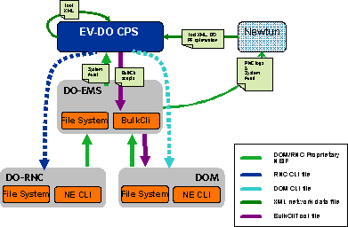

There are two formats of script that can be generated:

1. NE CLI script: used for Greenfield network or new NE addition into an existing network –
Replacing the ETool
2. BulkCLI script: used for RF reconfiguration on in-service NE on an existing network. –
Replacing the EV-DO Editor

CPS 1xEV-DO Management Functions include:
- Import/Export Facilities
- Import EMS generated System Audits
- Import/Export workspaces, snapshots, templates and work orders
- Network Management
- Tree and Grid Visualization of Network
- Launce Point for Wizards and Operations
- Work Orders Management
- View configuration changes from baseline audit/snapshot
- Templates Management
- View, Edit and Save Templates for DOMs and RNCs
- Datasets Management
- Create subsets of nodes or nodal objects for management
- Checks Management
- Create custom check profiles and review check sessions

The CPS Tool User’s Guide and CPS Operations Guide are available from Nortel.Com link.

The CPS tool is delivered through the Nortel Technical Support website at: https://support.nortel.com/go/main.jsp?cscat=SOFTWARE&poid=14861&viewOptSelect=4|3 and is available at no charge.

Installation Methods

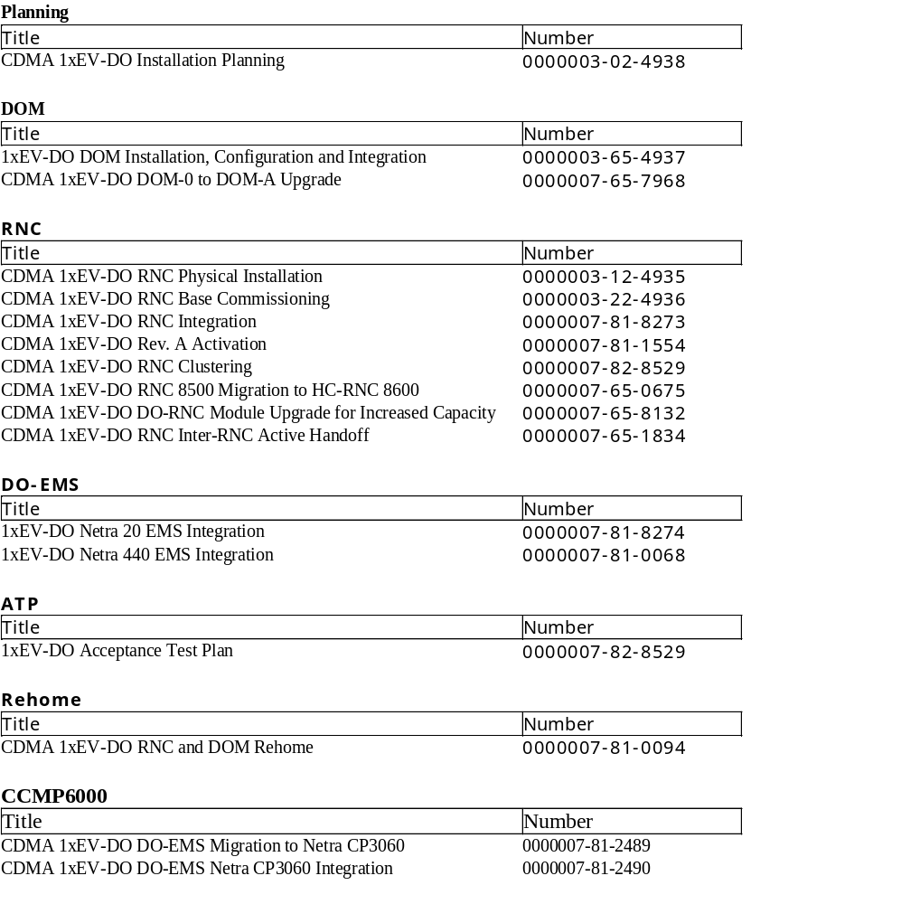
It is recommended that for installation and integration activities, field teams/primes begin by referencing the 02-4938 EVDO Installation Planning Guide. This document provides a mapping of the relevant IMs/IMOPs that are used in installation/integration of each of the key network elements in the DO network. This mapping should enable field personnel to quickly identify the documents that are necessary, depending on which network element is being deployed (DOM, RNC or EMS).

The GIS book code for 1xEV-DO is CDMA28.
http://gis.us.nortel.com/cgi-bin/logon/logon.pl

Integration Methods of Procedure Strategy
Integration Methods of Procedure (iMOP) are a custom funded process specifically for each customer application. iMOPs may be developed by regional engineering or acceptance teams using the following input sources.
- Installation Methods
- Completed CIQ
- Provisioning guide NTP (and other NTPs as applicable)
- Verification/validation in lab by Regional Engineering

No changes to the Integration IMOPs were required for this release.

The GIS book code is CDMA28.

http://gis.us.nortel.com/cgi-bin/logon/logon.pl

At this website you will follow the steps listed to find the 1xEV-DO documents:

  - Wireless
    - CDMA
      - 19 CDMA BTS Systems
        - 28 3G High Speed Data

CDMA 1xEV-DO Installation Planning: 3-2-4938 provides a mapping of applicable IMs and IMOPs, depending on which node is in question.

The Bulk CLI tool enables the execution of a set of CLI commands on a specified group of Network Elements (NEs), which facilitates command line operations that must be performed across multiple NEs. After executing the tool once, the defined set of CLI commands are executed over Telnet connections to the target NE or NEs. For example, the tool can be used to periodically change the NE user account password on all NEs. This tool is documented in NTP 411-2133-934, Tools Guide.

Acceptance Test Strategy
The ATP for a 1xEV-DO network is found on the GIS web site: 1xEV-DO ATP 7-82-8529

No changes were required for this release.

Installation Return Process for non In-Service Nodes
The Installation Return (IR) process is documented below. The IR process should be followed to return suspected faulty hardware for systems that have not yet been placed into service. The existing process of contacting the ISC for support will be implemented.

For IR/RMA request the Installation personnel/Customer may contact the Installation Service Center at
1-800-473-7766 (800-4RESPONse) or Via Email
- Option 3, 3 US/ Asia Pacific Regions (Wireline/Wireless) OR Email usapisc@nortelnetworks.com
- Option 3, 2 Canada (Wireline/Wireless) OR Email canadisc@nortelnetworks.com
- Option 3, 4 US/Canada/Asia Pacific Regions (Optical/Passport/Voice Portal) OR Email optisc@nortelnetworks.com

Online IR/RMA submission form: http://www.nortel.com/servsup/isc/iscdoaform.html

Requests submitted will require the following information in order to process an IR:
- Name of Requestor
- Requestor’s call back number
- COEO number/ Order number/SAP PO#
- PEC Code/CPC
- Quantity
- Reason for Failure (Provide as much detail as possible.) or Reason for IR
- Serial Number (For Packs/Shelves/Frames)
- Ship To Address
- ATTN to Name and Phone Number

Nortel Installs – Support between H and K dates (up to ICN signing)
Customer Installs – Support for 30 days for missing/shortages/wrong type issues; 90 days for defects

The requestor will be given the IR # and RMA #. The return material should be clearly marked with the RMA # on the outside of the box and made ready for pickup at the agreed time and location.

Ryder ISC Webpage Link: http://47.156.160.19:8070/LMC/Index.html

Software Installation/Upgrade
The release upgrade procedures are captured in:
- 411-2133-209 Upgrade Procedures Release 8.0.x.x. to 8.0 .y.y
- 411-2133-211 Upgrade Procedures Release 7.0. to 8.0

In order to upgrade to Release 8.0, all the 1xEV-DO elements must be on DO Release 7.0. The BTS and BSC must be at NBSS16.0 prior to the DOM being loaded with DO Release 8.0.
The sequence of upgrade will be first from DO-EMS, then DO-RNC and lastly DOM.

The upgrade process is intended to maximize the amount of work that can be completed outside the maintenance window, in preparation for an actual upgrade, and minimizing the amount of network node downtime.

EMS Operational Enh
Release 8.0 Upgrade Path

Rel 7.0
Direct path*
Rel 8.0
*Direct Path = nodes able to operate at this s/w version for sustained length of time; rollback path is reverse of upgrade plan.
Actual loading sequence should be identical to EV-DO Rev0.
DOM-A
CSM 6800
DOM-0
CSM 5500
RNC
EMS
ATT Paging
ROT
TCA for ACH and CCH
ATT Paging
Cluster LB
NE Robustness
RNSM LB

EMS GUI Enh
Royalty Licensing
EMS Operational Enh
CPS
Features
HW Chg
SW Chg
No
Yes
Yes
Yes
Yes
No
No
No
7.0.1.x
7.0.1.x
No UPGRADE PATH
7.0.1.x
7.0.1.x
CDOR0070 CDOE0070
CDOE0071
CDOR0080 CDOE0080
CDON0080

Loading Sequence
DO-EMS
DO-RNC
RNM
BIO
SC
DOM’ s
16.0 Metro Cell /
Compact BTS
BSSM
CEMS

Rollback sequence is the reverse of the loading sequence.

For specific details, please refer to the following NTPs:
- 411-2133-209 Upgrade Procedures Release 8.0.x.x to 8.0.y.y
- 411-2133-211 Upgrade Procedures Release 7.0. to 8.0

- These NTPs can be found on the Nortel Portal at NN.COM
- To Search for CDMA Documents,
  - Nortel.Com
    - Technical Support & Log in to the page
      - Wireless Networks
        - CDMA Networks

Field teams, contact the GPS team (Rhavi Gopalakrishnan, Arif Yousef) for additional details.

New Feature Provisioning
There are new features to be provisioned in the 8.0 release. Release 8.0 feature provisioning instructions are located in the EV-DO Deployment Planning NTP (411-2133-932).

Operate/Maintain Phase
The Operate/Maintain phase defines the period after the product/solution has been accepted by the customer.

Key functional teams involved during this phase include Software Services, Training, and Technical Support.

Service Entitlements
For access to the Service Entitlement Form (SEF), please click on the following URL: Service Entitlement Link.

Customer Documentation

Table 3: NTP List
1xEV-DO Release 8.0 - Customer Documents
Document # | Document Title
411-2133-013 | EV-DO Configuration - Common Provisioning System
411-2133-014 | EV-DO Common Provisioning System Operations
411-2133-109 V1 / V2 | Release Delta for 1xEV-DO 8.0 to 8.0 RNC 9000 Vol 1 / Vol 2
411-2133-126 | 1xEV-DO DO-EMS Software Installation
411-2133-209 | 1xEV-DO Upgrade Procedures R8.0 RNC 9000.X to R8.0 RNC 9000.Y
411-2133-211 | 1xEV-DO Upgrade Procedures R8.0.0.X to R8.0 RNC 9000.Y
411-2133-212 | 1xEV-DO EV-DO New in this Release
411-2133-214 | 1xEV-DO Fundamentals - A Priori Resource Allocation
411-2133-215 | Recommended RF Datafill for 1xEV-DO for Release 8.0 RNC 9000
411-2133-514 | 1xEV-DO RAN Overview
411-2133-529 | 1xEV-DO DO-EMS Administration
411-2133-814 | 1xEV-DO Radio Access Network Engineering
411-2133-815 | 1xEV-DO Alarms Reference
411-2133-816 | 1xEV-DO DOM Hardware
411-2133-817 | 1xEV-DO 8500/8600 DO-RNC Hardware
411-2133-822 | 1xEV-DO Configuration Parameters Reference
411-2133-924 | 1xEV-DO Performance Measurements Reference
411-2133-925 | 1xEV-DO CLI Reference - Network Elements
411-2133-926 | 1xEV-DO Logs Reference
411-2133-927 | 1xEV-DO Using the DO-EMS Interface
411-2133-932 | 1xEV-DO Deployment Planning
411-2133-934 | 1xEV-DO DO-EMS Tools Reference
411-2133-949 | 1xEV-DO Fault Management
411-2133-950 | 1xEV-DO CLI Reference -- DO-EMS
(NBSS & DO) CCMP6000-SUN-915 | Hardware Replacement Procedures Sun
(NBSS & DO) NN20000-915 | CCMP6000 Fundamentals

NTP Number | Description
411-2133-013 | Describes how to use the Common Provisioning System (CPS).
411-2133-014 | Describes how to configure the Common Provisioning System (CPS).
411-2133-109 V1 / V2 | Volume 1 and Volume 2 of reference manual. Contains detailed functional descriptions, planning and engineering, upgrade, configuration, administration/security, fault and performance information for the latest 1xEVDO release features.
411-2133-126 | Describes how to install both platform software and the DO-EMS application software onto your Netra CP3060 and Netra 440 servers.
411-2133-209 | Provides the procedures for the network component upgrade and rollback from one build to another within the same release. For detailed load lineup information, see the appropriate Appendix in the customer release notes.
411-2133-211 | Provides the procedures for the network component upgrade and rollback from one release to the next. For detailed load lineup information, see the appropriate Appendix in the customer release notes.
411-2133-212 | Describes where the 1xEV-DO new features are documented.
411-2133-215 | Provides recommended 1xEV-DO RF datafill for the release.
411-2133-514 | Describes the architecture of different 1xEV-DO RAN modules and how these modules interact with each other to establish a data call. The NTP discusses software architecture, call flow scenarios and the capacity of different modules in the DO-RNC and potential bottlenecks and DO-RNC redundancy for each module.
411-2133-529 | Provides information for maintaining and administering the DO-EMS server
411-2133-814 | Provides guidelines on Radio Access Network engineering.
411-2133-815 | Complete reference material for 1xEV-DO alarms.
411-2133-816 | Contains information on the 1xEV-DO module (DOM) hardware and how to invoke and interpret various tests.
411-2133-817 | Describes the DO-8500 and 8600 hardware and system components.
411-2133-822 | Provides information on the configurable parameters and how to configure network elements.
411-2133-924 | Provides information on the 1xEV-DO performance metrics and includes related OM and metric information.
411-2133-925 | Describes the 1xEV-DO command Line Interface (CLI) and provides complete reference material for each CLI command.
411-2133-926 | Desbribes the logging subsystem messages generated by 1xEV-DO network elements.
411-2133-927 | Provides scalable, web-based remote management for all-IP 1xEVDO access network.
411-2133-932 | Describes a typical 1xEV-DO network deployment including hardware, software and datafill that are needed for a successful deployment.
411-2133-934 | Describes the DO-EMS tools available for managin the 1xEV-DO radio access network.
411-2133-949 | Descbibes the 1xEV-DO fault management including troubleshooting procedures and flow charts.
411-2133-950 | Describes the 1xEV-DO EMS CLI (command line interface) and the Control App CLI with descriptions of each CLI command.

Channel Ready NTPs are available on the Nortel Portal at NN.COM
- To Search for CDMA Documents,
  - Nortel.Com
    - Technical Support & Log in to the page
      - Wireless Networks
        - CDMA Networks

Nortel Internal Training
Internal knowledge transfer sessions have been presented and have been incorporated in regional readiness assessments. These courses have been recorded and archived for repeated playback. Courses include a presentation package as a supplement to the course. The list of recorded knowledge transfers for EV-DO 8.0 is provided below:

1XEVDO 8.0 Internal Only KT Sessions
EV-DO Rls 8.0 POR Presentation
NTPs and Training
Special Session on NTP Organization and updates for 8.0
Newton - New Features Under EV.DO 8.0 Presentation and Demo
HW/SW Rules Engineering, ME's and SW CIQ
Centralized Engineering Solution (CES) Hardware Part 1
Centralized Engineering Solution (CES) Logical Part 2
EVDO 8.0 CIQ
1xEV-DO 8_0 KPI/KCI, Call Flow KT
1xEV-DO 8_0 IP Address Planning KT
1xEV-DO 8_0 Updates to Clustering KT
1xEV-DO 8_0 Call model overview KT
Inter-Subnet Border Enhancements KT/Per application paging KT
MB-ROT KT
ACH CCH Threshold Crossing Alarms KT
EV-DO 8.0 DOM Configuration in CPS and RF Reconfiguration for Network Engineering
CPS for 1xEV-DO Rls 8.0 Overall E2E Deployment Process and DO-RNC Configuration in CPS for Network Engineering
EV DO Rls 8.0 Changes to WPP
-Intro Gerardo
-Library Parser/Loader Maria Trinh
-EVDO Reports Scott Ames
1xEV-DO 8.0 Update to RNC Clustering
1xEV-DO 8.0 VO Deployment Round Table
1x EV-DO Rls. 8.0 Project Management Tools and Processes

All KT’s have been archived on Livelink including the presentation and recording at

URL :
http://livelink-ott.ca.nortel.com/livelink/livelink.exe?func=ll&objId=33046426&objAction=browse&sort=name&viewType=1

Nortel Networks University (NNU) also has a course available to Nortel employees:
1xEV-DO Rev A Release 8.0
http://navigate.us.nortel.com/imds?pg=/sales/nnu/wls/1xevdor70324

Carrier Grade, Real-Time Apps over Rev A and IMS
http://navigate.us.nortel.com/imds?pg=/sales/nnu/wls/carriergraderealtime

PTT and PTV over Rev A and IMS
http://navigate.us.nortel.com/imds?pg=/sales/nnu/wls/pttptv0924

External / Customer Training
All of the external / Customer training has been updated with Release 8.0 material.

The following courses were updated for release 8.0
- 4526F CDMA 1x EV-DO 8.0 Knowledge Transfer
- 4524A CDMA 1xEVDO 4524A - CDMA 1xEV-DO Operations and Maintenance
- 4529F CDMA 1xEVDO Features for System Performance Optimization
- 4543A Introduction to 1xEVDO System Performance and Optimization
- 4550A CDMA CPS Configuration

Table 4: Formal Training Courses -
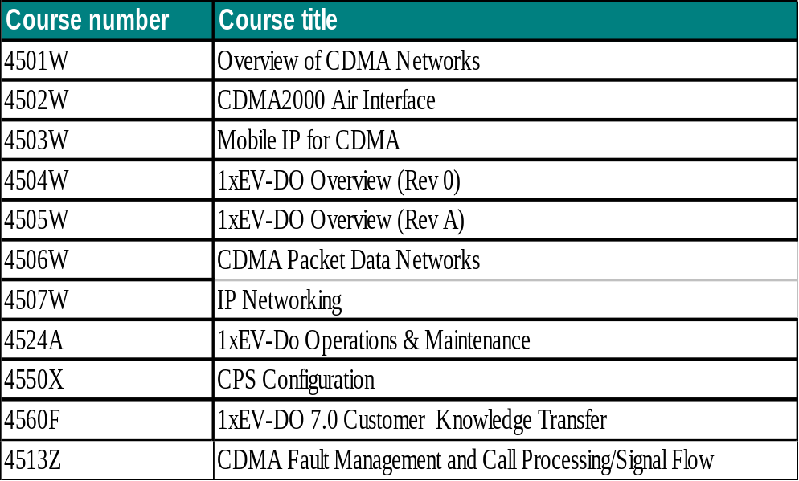

For a complete list of available training, access the Nortel.com training web site: http://www.nortel.com/training

Performance Monitoring
Product performance must be monitored on a regular basis with reporting archived for future analysis.

Utilizing the Network Performance indicators and formulas
Performance indicators are described in the 1xEV-DO Performance Measurements Reference, number 411-2133-924 in the NTP suite. Specifically reference these sections:
- 1xEV-DO Session Setup and A13-Dormant Handoff Performance.
- A10 Connection Performance
- Terminal Authentication Performance
- 1xEV-DO Connection Setup Performance
- 1xEV-DO Connection Close Measurement
- Handoff Performance
- Multi-Revision Operation Measurements
- Paging performance
- Data over Signaling (DoS) Measurements
- Quality of Service (QoS) Performance Measurement
- Sector Physical Layer and MAC Layer Measurements
- Capacity and Utilization Measurement
- DOM Connection Resources Usage
- Average Connection Duration and Soft Handoff Factors
- Overload Control Measurements
- Multilink PPP (MLPPP) and T1E1 Quality Measurements
- RLP Performance
- DO-EMS OMs

The 1xEV-DO R8.0 Capacity VO report is available at this location: http://livelink.us.nortel.com/objectid/12472404

Key Performance Indicators/Key Capacity Indicators
The 1xEV-DO Release 8.0 KPI / KCI presentation package is available at the link below. There were no changes to the KPIs and KCIs in Release 8.0.

See KT presentation and recording at http://livelink-ott.ca.nortel.com/livelink/livelink.exe?func=ll&objId=15578457&objAction=browse&sort=name&viewType=1

Product Performance – WPP – Nortel Wireless Performance Portal
The Nortel Wireless Performance Portal (WPP) service is a web-based subscription service that provides a managed performance reporting system for wireless operators and helps to potentially increase total system quality and lower operational and network maintenance costs. The foundation of the service is industry-leading performance collection and reporting systems directly connected to customer networks.

WPP provides regular, daily monitoring reports of vital network information for CDMA wireless technology. The service provides secure, on-line access to reports of call performance measurements, system resource usage and traffic data extracted from the customer’s wireless network. This information has proven critical for customer network planning and engineering organizations, as well as for the various Nortel teams (such as Network Engineering, ETAS, Product Design, etc.) supporting customer’s network.

WPP is OAM performance reporting service that:
- Extracts Customer’s network data - Configurable based on customer needs
- Provides raw and parsed data through secure web portal
- Applies engineering formulas defined by Nortel system engineering experts
- Generates a comprehensive set of performance reports and delivers the reports through secure web portal

WPP supports all Nortel CDMA wireless products:
- Circuit and Packet
- 1xRTT and EVDO
- PDSN

WPP delivers a complete package of comprehensive reports aligned with every Nortel software and product release. The WPP service for CDMA delivers three main capabilities. These features include (1) collecting raw statistical counters and log files from customer network elements every 30 or 60 minutes, processing the raw data into Nortel-recommended key performance indicators and performance reports, and (2) presenting these reports to the WPP service end-user via a web portal. The development of the baseline set of performance reports is defined and validated by Nortel Core Engineering and Product System Engineering.
The WPP Service also provides (3) custom reporting capabilities to the end-users, who can build their own set of reports, as required and in addition to the Nortel set of recommended reports. The custom reports can be created and scheduled to run via the web interface provided by Nortel.
Nortel ensures the security of the customer’s network performance data by using the following industry best practices:
- Secure IP VPN connectivity through the firewalls
- Secure “RedLAN” Computing Environment with integrated Business Continuity Plans. The Business Continuity Plan includes daily and weekly backups.
- Enhanced Security (SAS70 Type II Ready) and Control
- Secure and partitioned protection of customer’s intellectual property.
The Wireless Performance Portal service covers the following technologies: CDMA (IS95), 1xRTT, 1xEV-DO and AMPS.

Data Collection
- 24 hour Data for all Network Elements near real time
- Keep Raw registers in DB
- Parsed registers in DB

Reports
- Report generation every 24 hours or based on agreement
- Report builder. Customer will have the capability to generate reports any time using web portal access
- Graphical capabilities, and threshold capabilities
- BBH Capabilities for all network elements
- Customer can request the addition of new reports or content for WPP

Quality
- Validated reports and formula description in reports

Maintenance
- No server maintenance required. Servers are at Nortel locations.
- No report maintenance. Nortel implements the reports release over release.

Release Notes - contains mapping between the supported templates/counters and database table/column names and can be found at URL:
http://livelink.us.nortel.com/livelink/livelink.exe?func=ll&objId=21387915&objAction=browse&sort=name&viewType=1

WPP Release 5.1 Content supports 1x-EVDO 7.0 as follows:
Total number of EVDO templates and counters supported in this release:

    - Templates: 101
    - Counters: 3419

    - Out of the 101 Templates
      - New: 0
      - Modified: 2
      - Carried Over: 99
      - Obsolete 1

  - New – counters are new for EVDO 7.0 and do not exist in EVDO 6.0
  - Modified– for a given template, new counters are added for EVDO 7.0
  - Carried Over– for a given template, the list of counters are the same for both EVDO 6.0 and 7.0

References for WPP Release 5.1 in support of 1xEV-DO 7.0 are:
1xEV-DO -- Performance Measurements Reference NTP 411-2133-924

- Definitions and Formulas for each report are located in Livelink at: http://livelink.us.nortel.com/livelink/livelink.exe?func=ll&objId=27049344&objAction=browse&sort=name&viewType=1

- Each report contains formula definition at the end of the report.

EV-DO 8.0 library is backward compatible and supports all EV-DO 5.0, EV-DO 6.0 and EVDO 7.0 data..

WPP Service Support
The Wireless Performance Portal service offers business hours support through the following means:
- For issues with access to the Wireless Performance Portal, the following support options are available:
  - Password Expirations or Changes: www.nortel.com/changepassword, or
  - Call 1800-4NORTEL, options 5, 1. Customer will be routed directly to the Nortel CallCenter. The representative will likely be able to address the access issue directly, while on the phone with the customer.
- For any other issues with the Wireless Performance Portal service, the following support options are available:
  - Submit your question or issue via the online submission form on the www.nortel.com/performance Portal.
  - Send an email to performance@nortel.com with a clear description of the issue. Email is monitored during working days and the customer will receive a response with a case number within 1 business day.
Call 1800-4NORTEL, option 1, Express Routing Code 7373. Customer will be routed directly to the Performance Portal administration support line. The analyst will receive the issue or question and provide a case number while the customer is on the phone. Alternatively, the customer can leave a voice message including a callback number and email address for clarification. Then a case number will be sent to the customer via email, once created. The voice mailbox is monitored at least 2 times per day and the case number should be received.

WPP Documentation
The following documentation will be provided:
- WPP Web Interface User guide
- Computer-based training session
- Integrated WPP Service context-sensitive reference to performance reports formulas used, as well as related NTPs.

WPP Marketing Collateral

Marketing Collateral can be found at URL: http://bizsphere.us.nortel.com/

Corrective Content
We currently offer our customer four levels of service for patch delivery. More information in the patching levels of services overview package. http://swf.ca.nortel.com/live/index.shtml
- Click on Patch Services on the left

Current EV-DO Patch Baseline
In order to better provide the field engineers, account managers and the customers, a Current Patch BaseLine outlines the latest EvDO patches that are available for site and patches that are still under testing.

The aim is to have it updated on a weekly basis and build on this, so that this would serve as a true guide to the EvDO patches.

Field teams: contact the GPS team (Rhavi Gopalakrishnan, Arif Yousef) for additional details.

Please obtain the package from EvDO Global Support ----> Patches -----> 'Patch-Current Baseline_mmmdd'

Link: http://livelink-ott.ca.nortel.com/livelink/livelink.exe?func=ll&objId=8903544&objAction=browse&sort=name

Web Posting
Patches are posted on www.nortel.com. The customer downloads patches from the website to the appropriate network elements. There is an electronic notification of fixes posted on the Web.

This solution contains various platform specific patch streams. Please ensure your customers are aware of the following locations to obtain corrective content:
- Cellular & Wireless Networking: CDMA Networks, CDMA 2000 1xEV-DO

Each product has an option on the left to be added to that user’s personal list. This will facilitate quicker access to the required information and the option for patch notifications.

Drop Box Delivery

Enhanced Drop Box
Nortel will download patches to customer server. The customer downloads patches from the server to the appropriate network elements. Delivery notification/reports made available to the customer.

Remote Distribution Disk (RDD) toolset
Nortel downloads patches to customer RDD and the customer uses RDD tools to transfer patches to their network.

Patch Download
Nortel downloads patches to customer’s network elements and the customer applies patches to network elements.

Corrective Content Management
Nortel downloads and applies patches to customer’s network elements and applies Maintenance Releases to customer’s network elements (where applicable). Nortel also removes obsolete patches and performs cleanup activities.

CDMA Load Lineup
The CDMA Load Lineup page, managed by the BSC GPS team, is a user intuitive and friendly interface to quickly discern the load line up of any CDMA Access release. Furthermore, it also provides the user with a delta versus the vaulted load with direct link to the updated LIP file.

The tool is dynamically linked to both the software vault and the WSS Database.

Unfortunately, this page is not customer accessible at this time.

Patch Disposition Reports
The 1xEV-DO Disposition Reports can be found at:
- Patch Disposition Report (Customer Visible)

Technical Support Model
Describe the process that must be followed to obtain support for this program.

- Tier 1 support is provided by TAS and/or Emergency Recovery, as needed
- TAS and Airvana Technical Services communicate directly and copy GPS to act in the case of misunderstanding, or on escalations

Required Tools
TAS tools for 1xEV-DO can be found at this location:
http://zrchs0j9.us.nortel.com/cgi/tastools/build_tools.pl?dir=evdo_tools

The TAS Tips pages for 1xEV-DO can be found here:
http://zrchs0j9.us.nortel.com/cgi/mghubb/tips/build_index1.pl?subsys=EVDO

The 1xEV-DO Global Product Support page contains links to relevant support information, CABs, Patches, Scripts, etc.:
http://livelink-ott.ca.nortel.com/livelink/livelink.exe?func=ll&objId=8777287&objAction=browse&sort=name

Health Check Procedure
The Health Check Procedure procedures are located in the NTP 411-2133-949, EV-DO Fault Management.

Product Clarify Queues
Only one queue should be utilized to support this program:

SU_PS_WRLS_CDMA_EVDO

Global Product Support Teams
Global Networks Product Support Accountability Map:
http://gpsam.ca.nortel.com/

GNPS Routing Map
The overall intent of the Global Networks Product Support (GNPS) Accountability Map is to map products and services to the accountable product support team. The GNPS Accountability Map covers: Clarify Queue IDs; Phone Number, Pager; Cell numbers; and Escalation Path.
http://gnpsam.ca.nortel.com/GNPSContactTool/index.html

Region: | Global
Product Family: | CDMA
Product Name: | 1x EV-DO

Keywords: Metrocell, CDMA, Access, PDSN, RNC, DOM (Data Only Module), DO-RNC (Data Only Radio Node Controller), DO-DOM, DO-EMS, EVDO, 1xEVDO, EMS, 1x EV-DO

Documentation

Service Level Agreements
The 1xEV-DO SLA is located at this location:
http://livelink-ott.ca.nortel.com/livelink/livelink.exe?func=ll&objId=9300127&objAction=browse&sort=name.

Data Collection Guide for RCA
This guide contains a listing of all required data to successfully perform a RCA. It contains a step by step list of commands used to collect data from the network to allow quality to be driven by field failures. The data collection steps should be prioritized in order of data preservation sensitivity.
- ER work instruction ER0001 contains links / instructions.
- CAB or GPS Bulletins will not suffice as they do not provide enough detailed information for ER to follow.
- GPS Web Page links or CLI Manager Scripts are preferential.
Note: ER will recover first, and then collect data. Data should be preserved on product or a automated script should be provided to reduce data collection duration. Data that is collect prior to recovery will be charged to product.

ER currently has 3 Work Instruction documents that contain data collection requirements for all products. Data from deliverable is transferred into one of 3 ER0001 work instructions:
- ER0001e – TDMA / CDMA Data Collection Guide

These documents provide GPS web links where instructions are provided to guide the ER Engineer to collect the required data for Root Cause to be successfully completed.
- EVDO RNC Data collection scripts:
- http://livelink.us.nortel.com/livelink/livelink.exe?func=ll&objId=8782776&objAction=browse&sort=name
- DOM Recovery Guide and Data Collection:
- http://livelink.us.nortel.com/livelink/livelink.exe/fetch/2000/8700939/4088676/4107467/5004523/5003612/8346016/8346191/8346296/8457570/DOM_Outage_Recovery_and_Data_Collection.pdf?nodeid=8459436&vernum=0
- EMS Recovery Guide and Data Collection:
- http://livelink.us.nortel.com/livelink/livelink.exe/8460079/EMS_Outage_Recovery_and_Data_Collection.pdf?func=doc.Fetch&nodeid=8460079
- RNC Recovery Guide and Data Collection:
- http://livelink.us.nortel.com/livelink/livelink.exe/8459554/RNC_Outage_Recovery_and_Data_Collection.pdf?func=doc.Fetch&nodeid=8459554

E1/E2 Criteria and Outage Impact Calculations
Provides ER the TL9000 P1 / P2 criteria used to classify product failures to Nortel E1 / E2 severity.
The E1/E2 criterion also includes card impacts where Passport or Shasta based products can have blade impact to nodal operation. ER will take the deliverable and update the ISO document TS609.3b (Wireless E1/E2 criteria) for ER and TAS to follow in product impact and severity classifications:
http://livelink.us.nortel.com/livelink/livelink.exe/8780830/TS609.3b_Wireless_Guidelines_for_SR_Priorites?func=doc.Fetch&nodeid=8780830

FCC Calculations
These tools provide Emergency Recover the ability to determine the impact of an E1 condition. ER references this deliverable to determine what the subscriber impact is for the Total or Partial E1 outage condition. For Passport or Shasta based products, this should also provide blade impact to nodal operation. The result of the Outage Calculation is then used by ER to populate Clarify Incident data.

Current method used is by resident product software such as OM calculation, Register attempt vs. success rate, Logs such as CPER, or non resident methods such as GPRS SGSN Blade outage calculation using Excel spreadsheets.

A method for ER to calculate FCC Potential Users, ER should be able to quickly locate the formula data and calculate whether or not the outage exceeded 900,000 potential user minutes. Commands and data fill entries are provided for ER to quickly locate and process statistics along with the formula or methodology to calculate potential user minutes.

FCC Outage Calculators can be found at this location:
http://livelink.us.nortel.com/livelink/livelink.exe?func=ll&objId=8132137&objAction=browse&sort=name

Validation Matrix

The Feature Validation Matrix is a slide in the VO To TAS Handoff Presentation.

Table 5: Validation Matrix
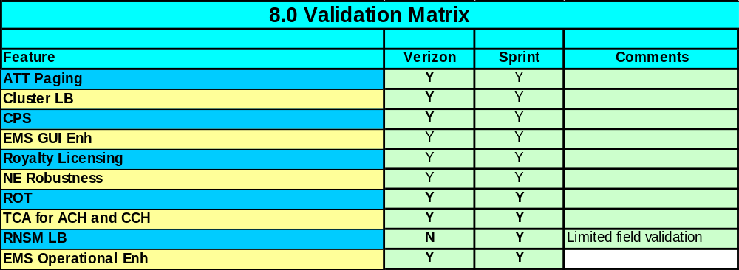
VO to TAS Channel Ready Handoff Presentation can be found at: http://livelink-ott.ca.nortel.com/livelink/livelink.exe?func=ll&objId=24859270&objAction=browse&sort=name&viewType=1GNPS Routing Map

No search words were added to GNPS for this release.

http://gnpsam.ca.nortel.com/GNPSContactTool/index.html

Repair & Return Process for In-Service Nodes
North American customers who require information for obtaining repair services for products purchased from Nortel should review the package available at this location:
http://navigate.us.nortel.com/imds?pg=/pss/service/rsp_advanceship&view=PreSales

The 1xEV-DO Product Service Plan has been posted, no changes were required with this release.

All Wireless PSP documents can be accessed at this location:
http://livelink-ott.ca.nortel.com/livelink/livelink.exe?func=ll&objId=14468709&objAction=browse&sort=name

The Global Customer Investigation Program (GCIP) Clarify Case Entry Process is to define all required information needed for meaningful Case data entry and collection. Information gathered from Clarify Clear Support is used for gathering technical knowledge databases for future product support and coordinating the direct shipment of hardware to the investigation location. Information for basic Case entry is presented. Advanced Clarify user information is outside the scope of this document.

Process Working Instruction Link
http://livelink.us.nortel.com/livelink/livelink.exe?func=ll&objId=3832226&objAction=browse&sort=name

Quality Link
http://navigate.us.nortel.com/imds?pg=/ops/qual/gcip

Global Customer Investigation Process (GCIP)
The Global Customer Investigation Process (GCIP) has been developed to provide a common approach for the return and investigation of non-functioning products during both the installation and in-service periods. The process establishes common definitions for the various types of investigations (Tier 0-4) and provides appropriate feedback to Nortel customers per our customer commitments or to the investigation requestor.

Through a partnership arrangement, Global Quality & Processes and Global Repair Services have undertaken the creation of the Global Customer Investigation Process (GCIP) to govern the investigation of returned material to Nortel. The investigation and Failure/Root Cause Analysis of returned material can provide Nortel with critical information that can be utilized to continually improve product quality, performance and reliability.

GCIP Link: http://gcip/

Communication

Product Release Notes

Most current version of the Product Release Notes are available at the following URL: www.nortel.com.
Go to SUPPORT & TRAINING -> TECHNICAL DOCUMENTATION -> Wireless Networks -> CDMA 2000 1xEV-DO -> SUPPORTING SOFTWARE and obtain "R8.0 Customer Release Notes ChR V1.X”

Wireless Customer Advisory Bulletins
Nortel employees should sign up with Lyris to receive bulletins. Here is the web page:
http://ztcfd0kk.ca.nortel.com/cgi-bin/lyrisasp.pl
- Put in your name (First then Last)
- Put in your outside email account or pager number
- Click on Product Bulletins at the top of the page
- Bulletin Function, highlight Technical
- Product Family, highlight the platform (hold down Ctrl key to pick multiple product families)
- Product Line, 'All Lines' or pick only what you need
- Product Filter, 'All Products', or pick only what you need
- Nortel Customers will continue to send requests to suznoble@nortel.com

Field Bulletins
The Global Bulletin Process is available at this location:
http://livelink-ott.ca.nortel.com/livelink/livelink.exe?func=ll&objId=8422615&objAction=browse&sort=name

The Clarify-Lyris Bulletin Notification system, is a self-subscribing tool that allow internal and external customers, the ability to receive email notifications upon publication of a product related bulletins, warnings, or alerts, which are generated via the Clarify ClearSupport Bulletin system.

Please reference Appendix A for a current list of Bulletin Coordinators/Products, that are currently utilizing this system; CBS_Lyris_Subscription_Process.ppt

Wireless Engineering Product Bulletins
To receive the 1xEV-DO RAN engineering bulletins, send an email to Michel Cazayoux.

References

Reference Links
- Deployment Planning Handbook
- Knowledge Transfers
- Integrated Project Team web site
- Wireless Project Mgmt Templates and Check Lists

Acronyms
1X | Single Speed
1xEV-DO | 1x Evolution, Data Optimized
1xRTT | 1.25 MHz Radio Transmission Technology
Abis | S0o03 RNC to BTS DOM Interoperability Specification.
AMPS | Advanced Mobile Phone System
AN | Access Network
ANET | Asynchronous Network
ANSI | American National Standards Institute
AP | Asia Pacific
API | Application Programming Interface
AT | Access Terminal
ASVS | Advanced Services
ATM | Asynchronous Transfer Mode
BCN | Base Station Communication Network
BCNW | BCN Wireless
BCP | Border Cell Paging
BE | Best Effort
BHCA | Busy Hour Call Attempts
BISC | BCN Inter-Shelf Communication
BIO | Base Input/Output Module
BIU | Base Station Interface Unit
BR | Business Ready
BSC | Base Station Controller
BSMCI | Base Station Manager Command Interface
BSSM | Base Station Subsystem Manager
BTS | Base Transceiver Station
BTS | Base Transceiver Station
CAB | Customer Advisory Bulletin
CACP | CDMA Access Configuration and Provisioning
CAD | C-EMS Application Desktop
CADES | Computer Aided DMS Engineering System
CaLA | Caribbean and Latin America
CAU | CDMA Application Unit
CBM | Core Billing Manager
CBRS | CDMA Backhaul Routing Subsystem
cBTS | Compact BTS (Indoor)
CCDS | Customer Capacity Delivery System
CCMC | Cable Consolidation and Multiplexer Chassis
CD | Compact Disk
CDMA | Code Division Multiple Access
CDR | Call Detail Record
CD-ROM | Compact Disk Read-Only Memory
CEM | Channel Element Module
C-EMS | CDMA Element Manager System
CES | Contivity Extranet Switch
CFDS | Customer Feature Delivery System
CG | Carrier Group
ChR | Channel Ready
CIQ | Customer Input Questionnaire
CIS | CDMA Interconnect System
CIU | CDMA Interface Unit
CLI | Command Line Interface
CLLI | Common Language Location Identifier
CM | Core Module
CMIC | Core Messaging Integrated Circuit
CMO | Compact Metrocell Outdoor
CNM | CDMA Network Manager
COL | Customer Operations Leader
CORBA | Common Object Request Broker Architecture
CPC | Component Part Code
CPDS | CDMA Packet Data Subsystem
CPS | Common Provisioning System
CPU | Central Processing Unit
CR | Customer Ready
CSL | Call Streaming Log
CSP | Communications Server Platform
CSS | CDMA Signaling Systems
CuR | Customer Ready
DAT | Digital Audio Tape
DBPE | Distance Based Paging Enhancements
DC | Data Collection
DDoS | Direct Data Over Signaling
DIRP | Device Independent Recording Package
DISCO | Distribution and Consolidation Unit
DMS | Digital Multiplex System
DNS | Domain Name Server
DOM | Data Only Module
DRC | Data Rate Control
DSC | Data Source Control
DTC | Digital Trunk Controller
EBSC | Enhanced Base Station Controller
eDCG | Enhanced Digital Control Group
EIU | Ethernet Interface Unit
EMEA | Europe, Middle East, and Africa
EMFPA | Enhanced Multi-Flow Packet Application
EMS | Element Management System
ENET | Enhanced Network
EOL | End Of Life
EP | Enhanced Paging
ER | Emergency Recovery
ESD | Electronic Software Delivery
ETSI | European Telecommunications Standards Institute
EUC | End User Certificate
EV-DO
FA | Foreign Agent
FER | Frame Error Rate
FLPP | Fiberized Link Peripheral Processor
FMA | First Market Application
FP | Functional Processor
FRS | Feature Requirements Specification
FRU | Field Repairable Unit
FTP | File Transfer Protocol
GB | Gigabyte
GCIP | Global Customer Investigation Program
GIS | Global Information System
GPS | Global Product Support
GSM | Global System for Mobile Telecommunication
GUI | Graphical User Interface
HA | Home Agent
HCMIC | High performance Core Messaging Interface Card
HHO | Hard Hand-Off
HLR | Home Location Register
HTTP | Hyper Text Transfer Protocol
HW | Hardware
I&C | Installation and Commissioning
I&C | Installation and Commissioning
ICN | Installation Completion Notice
ICP | Integrated Cellular Peripheral
IDL | Interface Definition Language
IDP | Internal Deployment Procedures
IM | Installation Method
IMOP | Integration Method of Procedure
IMSI | International Mobile Subscriber Identifier
IOM | Input/Output Module
IOP | Input/Output Processor
IOS | Integrated Office Systems
IOT | Inter-Operability Test
IP | Internet Protocol
IPSEC | IP Security Protocols
IPV4 | Internet Protocol Version 4
IPV6 | Internet Protocol Version 6
IR | Installation Return
IS | Interim Standard
ISC | Installation Service Center
ISO | International Organization for Standardization
ISP | Internet Service Provider
ISSHO | Inter-System Soft Hand-Off
ISTL | Inter-Shelf Traffic Link
ISUP | ISDN User Part
IZP | Intelligent Zone Paging
JAN | Job Activity Notice
KPI | Key Performance Indicator
KTS | Knowledge Transfer Session
L2TP | Layer 2 Tunneling Protocol
LAC | L2TP Access Concentrator
LAES | Lawfully Authorized Electronic Surveillance
LAN | Local Area Network
LBS | Location Based Services
LFP | IP File Patch
LNS | l2TP Network Server
LOB | Line of Business
LPP | Link Peripheral Processor
MAC | Media Access Control
Mbps | Million Bits Per Second
MCTA | Multi-carrier Traffic Allocation
MDM | Multi-service Data Manager
MDP | Management Data Provider
ME | Material Estimate
MFRM | Multiple Frequency Radio Module
MHz | Megahertz
MIB | Management Information Base
MIF | Marketing Information Forecasting
MIP | Mobile IP Protocol
MNCL | Maintenance Non-Core module Load
MO | Managed Object
MPC | Mobile Position Center
MPCAP | Mobile Position Capability
MRS | Minimum Requirements Specification
MS | Message Switch
MSC | Mobile Switching Center
MSCID | Mobile Switching Center Identifier
MSS | Message Subscription Server
MSW | Multi-service Wireless
MTBF | Mean Time between Failures
MTX | Mobile Telephone Exchange
NA | North America
NBSS | Nortel Base Station Subsystem
NCL | Non-Core module Load
ND | Network Design
NE | Network Element
NEBS | Network Equipment-Building System
NISR | Network Initiated Session Restoration
NOIS | Network Operation Interface Specification
NSLI | Nortel Site Location Identifier
NTP | Nortel Technical Publication
OAM | Operation Administration and Maintenance
OEM | Other Equipment Manufacturers
OM | Operational Measurement
ONP | One Night Procedure
ORCM | Origination Continuation Message
OS | Operating System
OSPF | Open Shortest Path First
OTA | Over The Air
PAC | Packet Accelerator Card
PC | Personal Computer
PCF | Packet Control Function
PCT | Passport Configuration Tool
PDE | Position Determination Equipment
PDN | Packet Data Network
PDP | Packet Data Protocol
PDSN | Packet Data Service Node
PEC | Product Engineering Code
PER | Packet Error Rate
PM | Peripheral Module
P-MSC | Packet MSC (also PMSC)
POR | Plan of Record
PPP | Point-to-Point Protocol
PSTN | Public Switched Telephone Network
PTT | Push To Talk
QoS | Quality of Service
RADIUS | Remote Authentication Dial-In User Service
RAM | Random Access Memory
RAN | Radio Access Network
RCA | Root Cause Analysis
RDD | Remote Distribution Disk
RF | Radio Frequency
RIP | Routing Information Protocol
RLP | Radio Link Protocol
RMA | Return Merchandise Authorization
RMU | Resource Management Unit
RN | Radio Nodule (DOM card)
RNC | Radio Network Controller
RNSM | Radio Node Server Module
ROT | Rise Over Thermal
R-P | Radio Protocol
RPS | Regional Patching System
RSVP | Resource Reservation Protocol
RTIF | Remote Terminal Interface
RTP | Research Triangle Park (System House)
SBS | Selector Bank Subsystem
SC | System Controller (card on RNC)
SCN | Service Completion Notice
SCO | Supply Chain Operations
SCP | Service Control Point
SCS | Service Creation System or Software Capacity & Scheduling
SDC | Software Distribution Center
SDD | Service Description Document
SDM | SuperNode Data Manager
SEF | Services Entitlement Form
SHO | Soft Handoff
SIF | Services Integration Form or Solution Integration Centre
SLM | System Load Module
SMS | Short Message Service
SMSC | Short Message Service Center
SOC | Software Optionality Control
SPC | Switch Processor Card
SPM | Spectrum Peripheral Module
SRS | Software Repository Server
STL | Saint Laurent (System House)
SW | Software
TAS | Technical Assistance Service
TBD | To Be Determined
TCA | Threshold Crossing Alarm
TCA | Traffic Allocation Assignment
TCP | Transmission Control Protocol
TDMA | Time Division Multiple Access
TFU | Timing Frequency Unit
TL | Telecommunication Laboratories
TL | Telecom Layer
TTBB | Trouble Ticketing Interface
TTBB | Trouble Ticketing Interface
U/G | Upgrade
UDP | User Data Protocol
UMTS | Universal Mobile Telecommunications Service
UNITE | Unified Networks Integrated Tool for Engineering
URL | Universal Resource Locator
US | United States
VAF | Value Added Feature
VLAN | Virtual Local Area Network
VO | Validation Office
VoIP | Voice over Internet Protocol
VPN | Virtual Private Network
WIN | Wireless Intelligent Network
WNE | Wireless Network Engineering
WNW | Wireless Networks Westwinds (Calgary System House)
WSS | Wireless Software Solutions
XA | Extended Architecture

